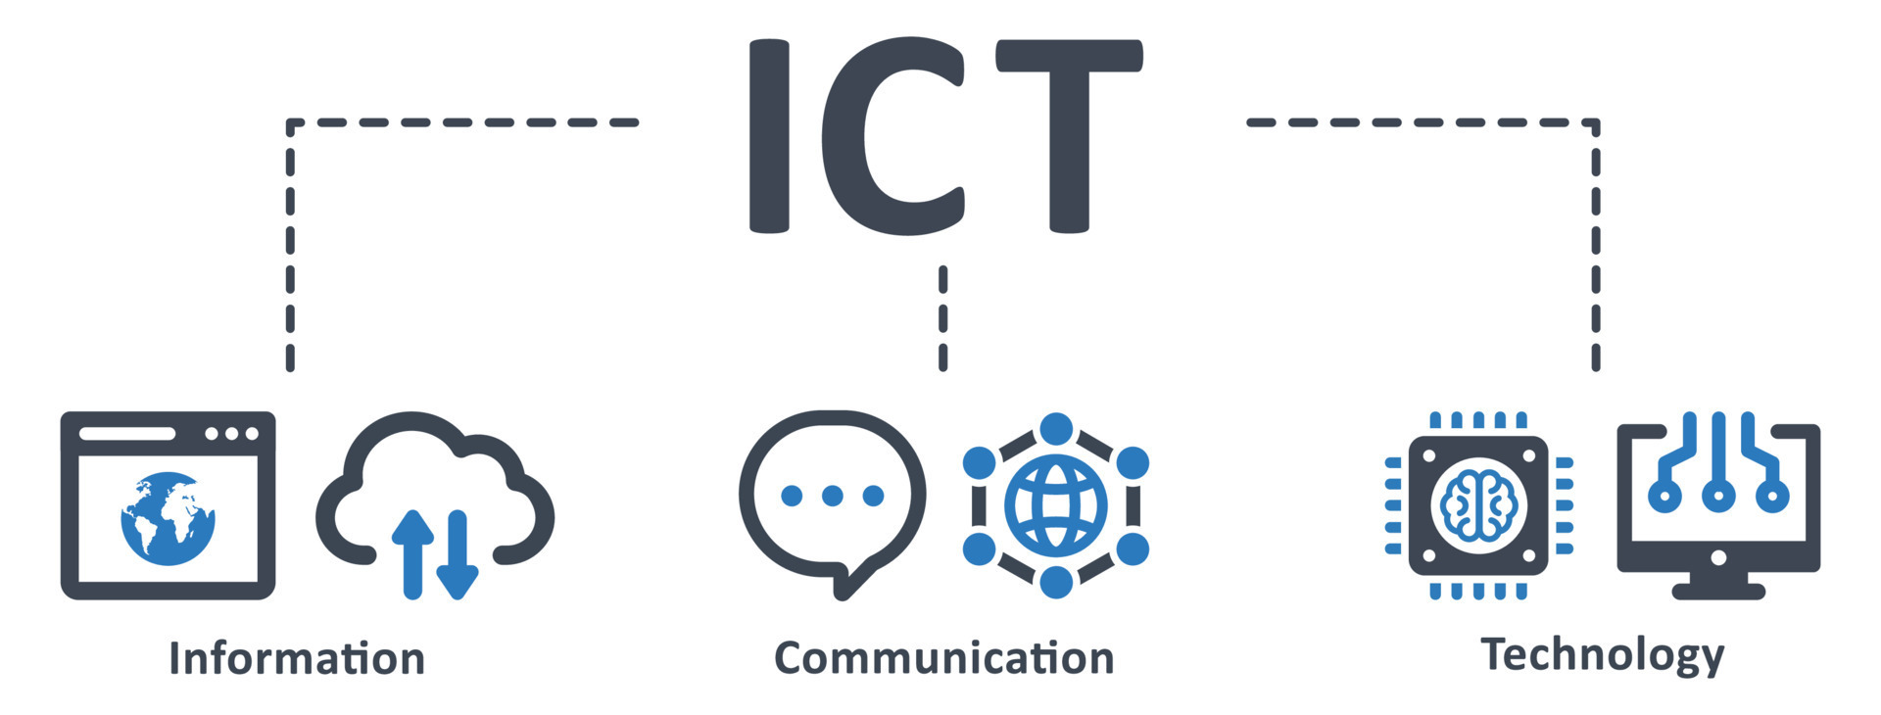

**Information and Communications Technology (ICT)**

**INTRODUCTION**

In today's world, Information & Communications Technology (ICT) plays a crucial role in driving innovation, transforming industries, and shaping how people interact, learn, and work. This project highlights the importance of ICT by focusing on the tools that enable efficient communication, information sharing, and problem-solving.

As a first-year student, this project aims to explore the basic tools of ICT, their functionalities, and how they can be applied to address everyday challenges. By understanding these tools, we can appreciate their role in enhancing productivity and creating opportunities for growth in various fields.

This project serves as an introduction to the transformative potential of ICT tools and their significance in our increasingly digital world, providing a foundation for further exploration and learning in the field.

**Why Tools Like Microsoft Office, HTML/CSS, GitHub, and LaTeX Are Essential?**

These tools play a crucial role in enhancing productivity, collaboration, and efficiency in various fields, making them indispensable in the modern ICT landscape.

**Microsoft Office**

Microsoft Office is a suite of productivity tools developed by Microsoft, designed to streamline and enhance tasks related to document creation, data management, and communication. It is one of the most widely used software packages in the world due to its versatility, user-friendliness, and powerful features

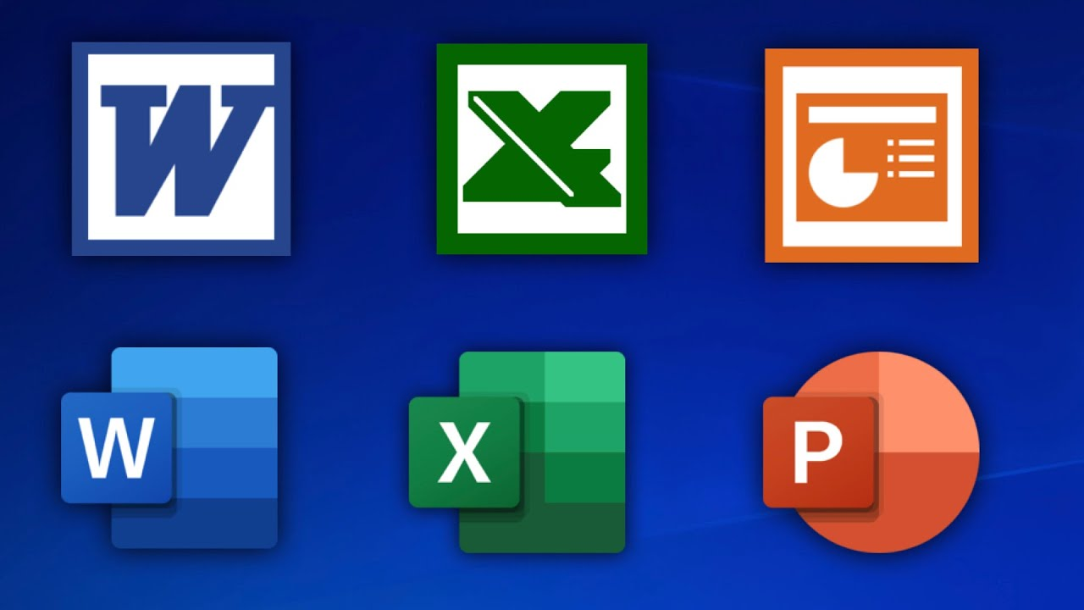

**Microsoft Word**:

Microsoft Word is a word processing application used for creating, editing, and formatting text documents.

**Key Features**:

Text Formatting: Change fonts, sizes, colors, and styles to create visually appealing documents.

Templates: Pre-designed layouts for resumes, reports, and letters.

Collaboration: Real-time editing with multiple users and commenting tools.

**Applications**:

Academic: Writing essays, research papers, and reports.

Professional: Drafting official letters, memos, and documentation.

Personal: Creating invitations, journals, or resumes.

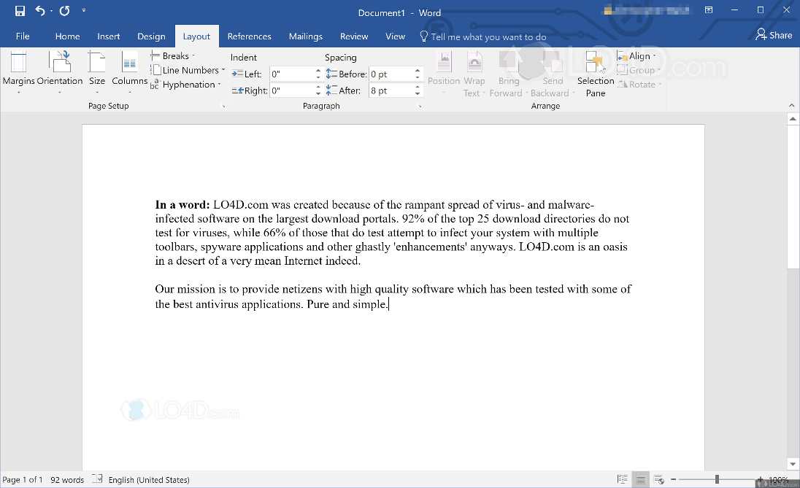

**Microsoft Excel**:

Excel is a spreadsheet application used for organizing, analyzing, and visualizing data.

**Key Features:**

Formulas and Functions: Perform calculations, from simple arithmetic to complex statistical analysis.

Charts and Graphs: Visualize data with pie charts, bar graphs, and scatter plots.

Pivot Tables: Summarize large datasets for easier interpretation.

**Applications**:

Academic: Managing grades, performing research data analysis.

Professional: Financial modeling, inventory tracking, and sales analysis.

Personal: Budget planning and tracking expenses

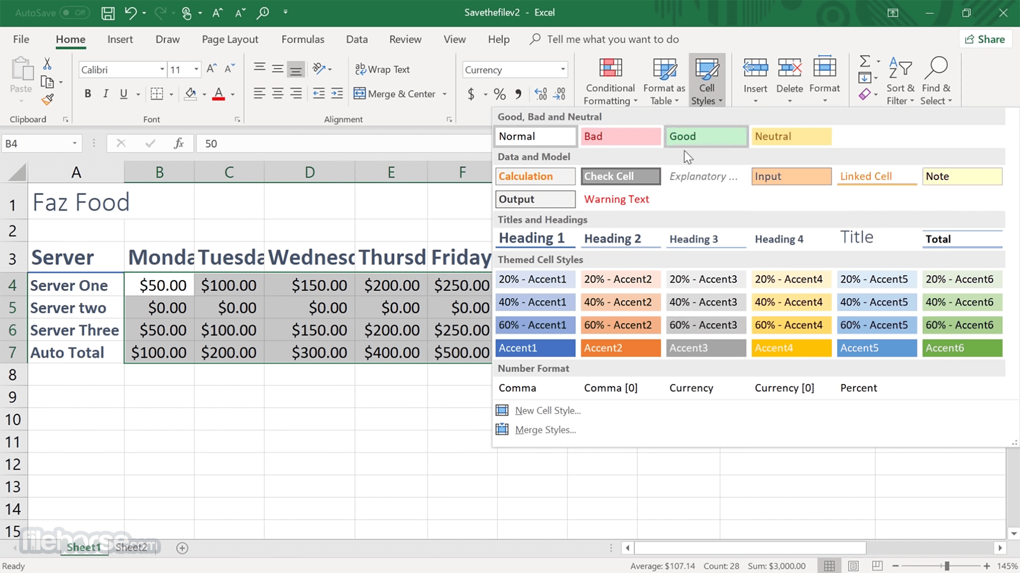

**Microsoft PowerPoint**:

PowerPoint is used for creating and delivering impactful presentations.

**Key Features**:

Customizable Slides: Add text, images, charts, videos, and animations.

Templates and Themes: Pre-designed layouts for professional presentations.

Transitions and Animations: Enhance engagement with visual effects.

**Applications**:

Academic: Presenting research, group projects, or lectures.

Professional: Pitching business ideas, training sessions, or company reports.

Personal: Creating photo slideshows or tutorials.

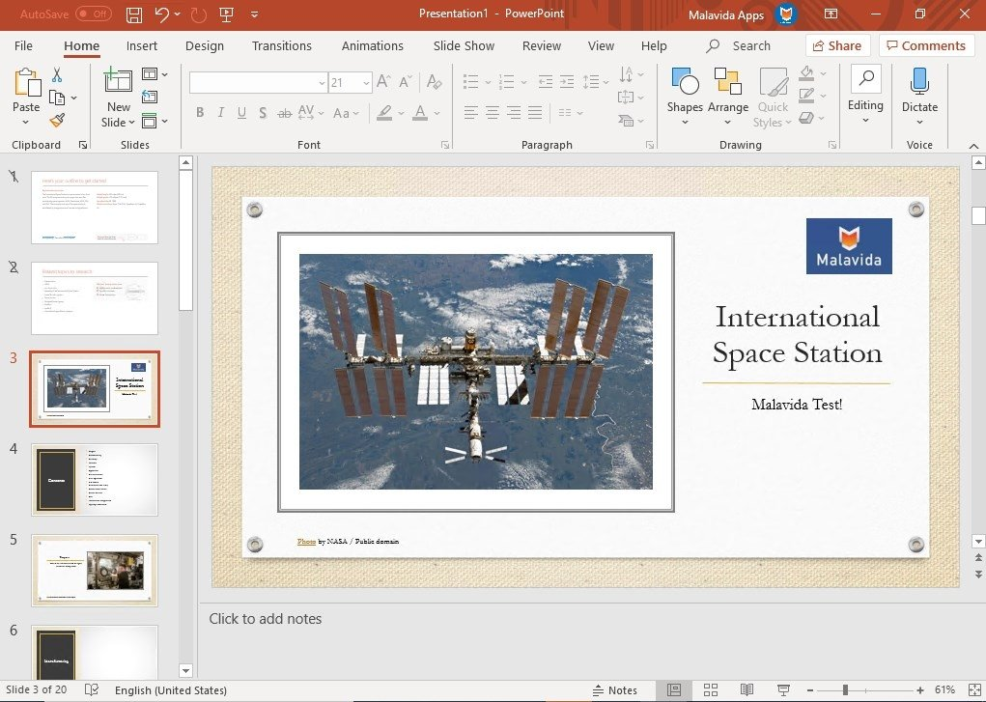

**Why Microsoft Office is Essential?**

**Wide Adoption**: Nearly every industry and educational institution uses Microsoft Office, making it a critical skill for students and professionals alike.

**Versatility**: Suitable for a wide range of tasks, from simple note-taking to advanced data analysis and presentation creation.

**Ease of Use**: Intuitive interfaces make it accessible to beginners while offering advanced features for experienced users.

Mastering Microsoft Office ensures productivity and efficiency in academic, professional, and personal settings, making it a cornerstone of ICT tools.

**HTML/CSS**

**HTML (Hypertext Markup Language)**

It is the standard language used to create the structure of a webpage. HTML defines elements such as headings, paragraphs, links, images, tables, and forms. It provides the skeleton of the web content.

**CSS (Cascading Style Sheets)**

It is used to style and visually present the HTML elements. CSS defines the layout, colors, fonts, margins, and spacing of the webpage, making it visually appealing and user-friendly.

**What is the importance of Web Design in ICT?**

**-Web Design** is crucial in ICT because it shapes how users interact with websites. A well-designed website can make information more accessible and improve the user experience (UX). It also builds trust and credibility.

-In **digital communication**, a website is often the first point of contact for users. An attractive, functional website helps communicate messages clearly and effectively, promoting engagement and conversions. Proper design also ensures accessibility, making content available to people with different needs and abilities.

*Good web design is a vital skill in the modern digital landscape, where attention to detail and user-centered design can significantly impact the success of online projects.*

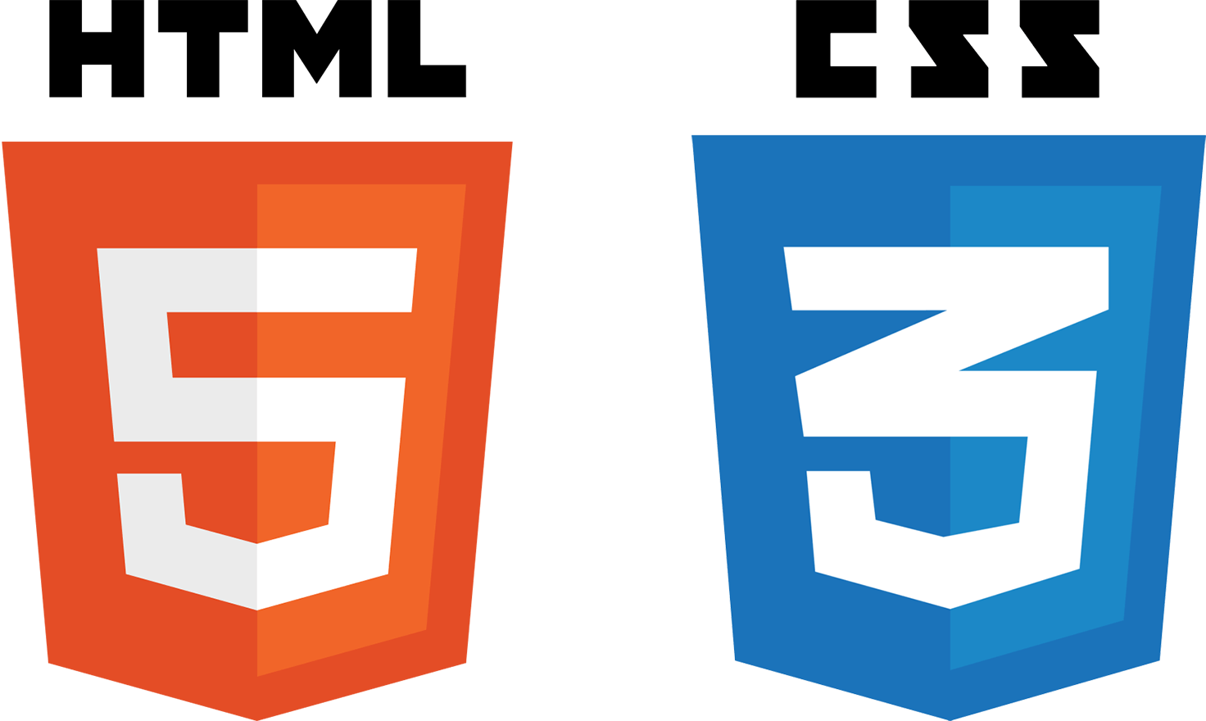

**GitHub**

GitHub is a web-based platform that leverages Git, a distributed version control system, to enable collaborative development and efficient project management.

**What is the importance of GitHub?**

**Version History:** Maintains a comprehensive history of changes to code and documents, allowing users to revert to previous versions if needed.

**Collaboration Tools:** Supports teamwork through features like pull requests for proposing changes, branches for isolated development, and issue tracking for organizing tasks and addressing bugs.

Code Review**:** Enables peer review and discussion of code changes, ensuring higher quality and better-informed development decisions.

**Open Source Contributions:** Facilitates global collaboration, making it possible for developers to contribute to open-source projects and learn from others' work.

**What are the use cases of GitHub?**

GitHub is extensively utilized in **software development** to manage projects, track bugs, and deploy applications. It is also crucial for **team projects** in academia and industry to foster organized workflows and efficient communication, and it also acts as a **showcase platform**, where developers present their work and build professional credibility in the tech community.



**LaTeX**

LaTeX is a powerful typesetting system designed for creating documents that demand precise formatting, such as research papers, technical reports, and academic presentations.

**What is the importance of LaTeX?**

Handles Complex Formatting**:** Efficiently manages intricate elements like mathematical equations, tables, figures, and citations.

Consistency and Precision**:** Ensures a uniform and professional appearance across all sections of a document.

Automation Features**:** Simplifies tasks like bibliography management, cross-referencing, and indexing, reducing manual errors.

**What are the use cases of LaTeX?**

Extensively utilized in **academia** for theses, dissertations, and scholarly publications.

Integral to **scientific and technical communities** for producing high-quality, publication-ready documents.

Preferred for **collaborative writing projects**, ensuring consistency in formatting and style, even with multiple contributors.

**CONCLUSION**

Mastering tools like Microsoft Office, HTML/CSS, GitHub, and LaTeX is essential in today's ICT-driven world. These tools enhance productivity, foster collaboration, and enable the creation of high-quality work across various domains. Microsoft Office supports versatile tasks like document creation and data analysis, while HTML/CSS empowers individuals to build and design websites. GitHub ensures efficient teamwork and version control, and LaTeX delivers precision in academic and professional document preparation. Together, these tools form a foundation for success in education, business, and technology, equipping individuals with the skills needed to thrive in the modern digital landscape.